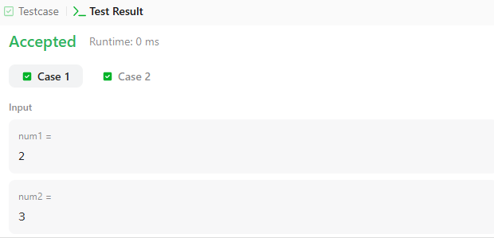

CODE-

int countOperations(int num1, int num2) {
int count = 0;

while (num1 != 0 && num2 != 0) {
if (num1 >= num2) {
num1 = num1 - num2;
}
else {
num2 = num2 - num1;
}

count++;
}

return count;
}

LINK-

https://leetcode.com/problems/count-odd-numbers-in-an-interval-range/

